Mario Arnedo

Administration site for an e-commerce

# Solution and develop

The solution to this development is to create a web service where people can listen to music in a simple way.

The development started from the front side, creating the databases and configuring the files to fit my needs. Once I had a couple of data uploaded, I started to create the backend, so I could manage and modify the elements to my own.

# Flow

The flow of this application starts from the opening of the URL ("/"), as we see, we have a big button, which will take us to the main service of this project, see and listen to music.

As we see, we also have a menu, which allows us to access the different sections of our page (login, register, and look at the authors that are on the page ...) 

For obvious reasons, only registered users can access the backend to manage the songs, you can access this backend if you put in the navigation bar tuproyecto/backend, if you are not logged in, you will see the login screen.

When you are logged in, you will enter the control panel of the web, where you can manage the songs that exist, you can delete, edit and even create new ones, the same happens with the authors and the "tags"

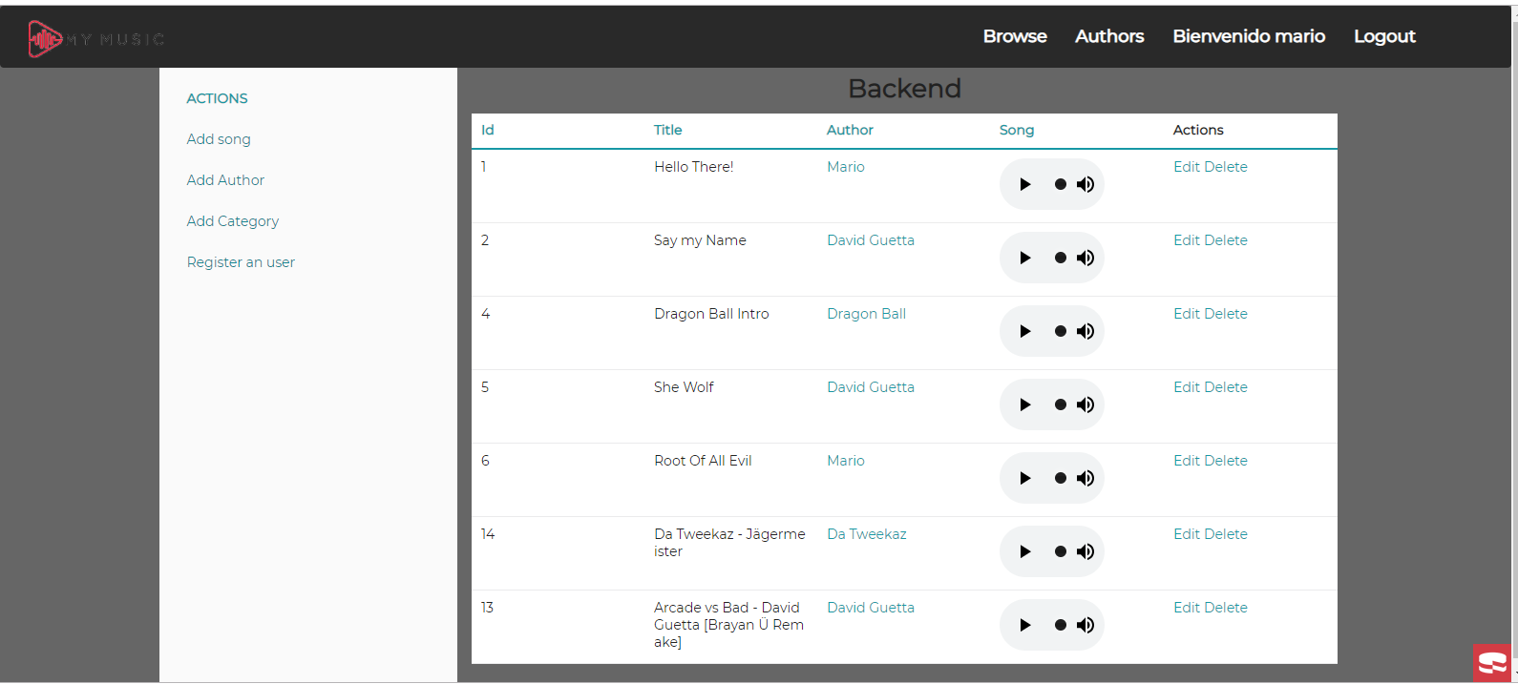

As you can see, the menu has already changed and has more elements, to be able to loosen up, apart from a welcome message.

When you logout, you will automatically be redirected to the home page and you will not be able to access the backend until you log in again.

If u click on anyone of the authors in the Browse section, u go to the page of the author that shows a Little description of himself and the songs that have in this page.

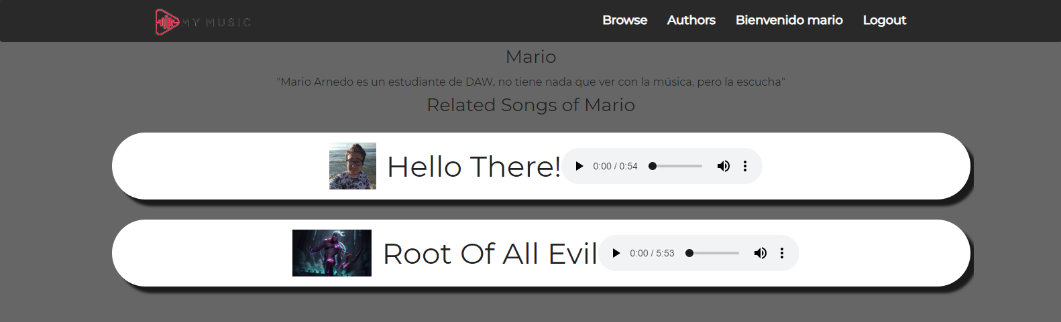

# Problems

My main problem was when trying to upload the files of the song, both the image and the song itself, but changing a couple of things as you said we got it out.

Also try to create a user management, making those who register can’t access the backend but did not get it, so I gave up.